Title of abstract <Arial, Bold, 14 points, Single spacing, Centered, 6pt paragraph spacing before and after>
^{1,*} Main Author, A.A., ^{1,2}Author, B.B., ²Author, C.C. and ³Author, D.D. <Arial, Regular, 12 points, Single spacing, Centering, 6pt paragraph spacing only after>
¹Affiliation, e.g: Institute for Energy Technology, Post Box 40, NO-2027 Kjeller, Norway
²Affiliation, e.g: Department of Materials Science, School of Chemistry, Madurai Kamaraj University, Madurai 625 021, India
³Affiliation <Times New Roman, Italic, 10 points, Single Spacing, Centered>
* Corresponding author e-mail: emailaddress@univeristy.com <Arial, Regular, 10 points, Single spacing, Centered>
One line space left intentionally
The authors are encouraged to submit a camera-ready abstract (A4-size with 2.5 cm margins on all sides). Type or paste your text into this file.
The abstract must not be longer than 2 pages and may include 1 figure and 1 table along with references therein. The title should be placed at the top, followed by the author name(s), affiliation(s) and address(es), and email address of the presenting author. The name of the presenting author should be underlined. The abstract text should be written in the Times New Roman font of 12 points in the single-spacing form and justification, as seen in this template. Please use 12 points single line spacing between each paragraph.
If your abstract includes digital photographs, please make sure that they are clearly visible. The captions should be added to the figures and tables. References, if present, should be referenced by the number “[1]” in the text, and listed at the end of the text as, e.g.,[1]. The figure and table caption should be written in the Times New Roman font of 10 points, single line spacing and centered.
The abstract will be published in the Abstract book. Abstracts that do not meet these formatting requirements will be returned. The organizing committee reserves the right to edit abstracts for clarity or correctness of English but will consult the author if any significant changes are needed.
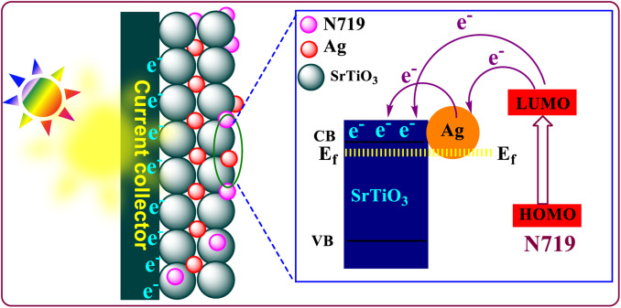

Figure 1: Schematic working mechanism of Ag-SrTiO3 NC photoanode based DSSC. <Times New Roman, Regular, 10 points, Single spacing, Centered>

Table 1: Comparison of photovoltaic performance of fabricated DSSC solar cells. <Times New Roman, Regular, 10 points, Single spacing, Justified>
Photoanode | J_{sc} (mA/cm²) | V_{oc} (V) | FF | η (%)
SrTiO₃ | 4.40 | 0.73 | 0.55 | 0.51
ZnO-SrTiO₃ | 11.65 | 0.62 | 0.54 | 3.9
<Times New Roman, Regular, 10 points, single spacing, centered & first row Bold>

- B. O’Regan, M. Grätzel, Nature, 353 (1991), pp. 737-740 <Times New Roman, Regular, 10 points, Single spacing, Left Alignment>
- M. Grätzel, Nature, 414 (2001), pp. 338-344
- Reference

